

MENTORING DIARY AND STUDENT’S PROGRESSION RECORD BOOK
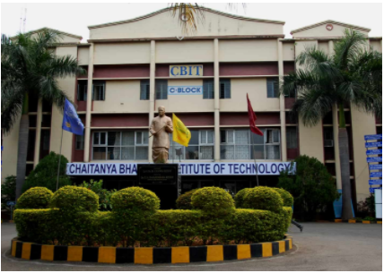
CHAITANYA BHARATHI INSTITUTE OF TECHNOLOGY (A)
(Established by CBES in 1979)
Affiliated to Osmania University, Accredited by NBA – AICTE & NAAC – UGC
ISO 9001:2015 Certified Institution
Chaitanya Bharathi (P.O), Gandipet, Hyderabad, Telangana – 500075 (T.S)
Ph: 8466997201, E-mail: principal@cbit.ac.inWeb : cbit.ac.in
MAY,2021

I . PREAMBLE:
This book is a record of Student’s progression and the mentoring activity conducted by the mentors to support their progression.
II . STUDENT’S PROGRESSION:
A process that ensures required progress of a student in terms of passing the examinations with good grades, acquiring knowledge in the subjects chosen and proper application of the same. It would be necessary to observe the progress of a student on a continuous basis and review periodically (monthly or fortnightly ) in order to support and facilitate student’s progression.
III . MENTORING:
Mentoring is a partnership between Mentor and Mentee. Mentors are student-centric teacher- friends who help young adult learners in their transitory phases and challenging times. It is based on mutual trust and respect. It has been introduced for obtaining a holistic assessment of the learners’ performance and providing inclusive spaces for growth and development. Mentors apply their guidance, experience, and expertise in promoting their mentees professionally and personally, through interpersonal engagement. They build bridges among various stakeholders (Students, Teachers, Parents, Principal, Management etc.)
(A). Objectives of Mentoring
• Creating opportunities amongst college groups & communities for bonding
• Refining teacher-student communication outside classroom
• Maintaining data base of student performance, attendance details & drop outs
• Supporting personal & professional growth & monitoring psychological growth & progress
• Identifying special talents, skills, slow learners & passing this information on, to the relevant committees
• Locating & solving attendance issues
• Providing sustained motivation
• Ensuring &providing feedback for parents and institute authorities as well
• Identifying learning needs
• Assisting in developing rights, responsibilities & values
• Provisioning a Comprehensive Personal Student Record
• Cultivating a healthy learning environment in college

(B). Expected Outcomes
• A healthy Learning Environment
• Vibrant Peer Group Exchanges
• Creation of positive communication channels among Principal, Parents, Staff & Students
• Enhancing a feeling of belonging among students
• Self confident, bold & an active, enthused student community
• Better attendance, lesser dropouts, and good psychological health of students
• Confident Parents
• Improved Performance
• Mentor Certificate
In short, Mentoring aspires to bring transformational positive changes. It augments self-confidence, improves peer bonding, and prepares mentees for career advancement.
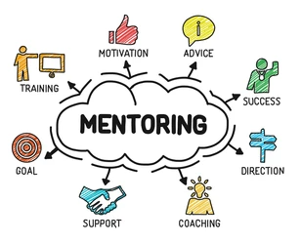
(C ). CBIT Student Mentoring System
Each faculty will be the mentor for a group of 20 to 25 students. First year students will have mentors from the department of basic sciences, Mathematics and Humanities and second, third, fourth year students will have mentors from the parent department. Departmental faculties will continue to be mentors for the same group of students till their graduation
(i). Roles and Responsibilities of Mentors
• Conduct an orientation meeting at the entry level (1st Semester/ 3rd Semester as the case may be ) for appraising them of the process & make them prepare an Orientation Report
• Select a spokesperson/representative for the group
• Collect data of mentees at every stage & also see that the students fill their data from their side without fail. Also ensure the authenticity of the data.
• On locating their need for marked improvement in certain areas (General/Academic/Career/Personal etc.,) refer the same to respective Heads of Departments
• Track the attendance and performance records & identify reasons, need if any, and prepare a Review Report with constructive suggestions
• Ensure frequent value added student visits to the library, Fitness center and other such, essentially in the allotted time slots and additionally in other permitted slots , if necessary.
• Allow & guide Peer Mentoring
• Refer distressed or disturbed cases to the Student Counselling Committee, through proper channel
• Notify to the Director-SA&P through proper channel about students with special talents
• Motivate them to take part in activities that can accrue more credits
• Compile their progress in performance through a Performance Chart & discuss threadbare with them, the details as the mentees produce the Mentor Certificate for career mobility and advanced studies.
• Identify reasons for poor performance & attach a note (illness, domestic disturbances, personal obstacles & so on)
• Meet them weekly, submit a report at least twice in a month to the HoD and record the same as a Review Report, to be sent to the Director-SA&P at least once in a month.
• A total of FOUR reports to be prepared and submitted (One Orientation & Three-Monthly Reports)
• Ensure holistic well being of Mentee by sticking to the following
- Continuously monitor, counsel, guide and motivate the students in all academic matters
- Advise students regarding choice of electives, project, summer training, MOOCs, Honours degree, etc.
- Contact parents / guardians if situation demands e.g., shortage of attendance, academic irregularities, negative behavioral changes and interpersonal relations, detrimental activities etc. (in co-ordination with the class teachers)
- Advise students in their career development/professional guidance
- Keep contact with the students even after their graduation
- Intimate HOD and suggest if any administrative action is called for
- Maintain a detailed progressive record of the student
- Maintain a brief but clear record of all discussions with students

- Mentor can assess and grade the students; but not for showing any discrimination.

(ii). Parameters for Mentee Assessment
Assessment by Mentors is a continually evolving process. It should be engaging and student- centric. Assessment rather than evaluation, supports student initiatives to help themselves in improving their performance. It focuses on certain criteria for grading the mentee such as whether the Mentee
1.Is Punctual 2. Undertakes responsibilities-Spokesperson/Leader/Peer Mentor or any other 3. Engages in Quality Voluntary Interaction, frequently 4. Undertakes Supportive/Positive/ Roles 5. Employs Personal Development Strategies-Seeks suggestions/is cordial in taking advice/is prompt in following instructions/ applies given inputs for personal improvement/ is meticulous in providing feedback 6. Develops Team Spirit& Team building initiatives 7. Cultivates commitment/remains accountable for his or her omissions & commissions 8. Has creative impulses & exhibits them in extra/co-curricular activities 9. Demonstrates healthy Interpersonal Skills 10. Promptly furnishes all the required data
Note: All the above criteria are graded equally. Each criterion is ascribed a value of 1 and the scores are calculated on a scale of 1 to 10.
GRADING KEY Performance Grade Scores Excellent- A+ :8 and above Very Good- A: 6 & 7 Good: B 5-6; Satisfactory –C: Up to 4.
The Mentor-Mentee interaction provides an opportunity to document the journey of a learner’s life. It is a portal for the mentee to carry his/her progress into the larger world space. Therefore, kindly generate the certificate with care and precision.
(iii). Roles and Responsibilities of Mentees
• Provide all the necessary data with relevant documents (Previous Academic Performance Records, documents for participation in extra/co curricular activities and academic advancement)
- Fill all the information that is sought from you in the prescribed format and location, at every stage as indicated in the ‘Mentor’s diary and student’s progress record book’.
• Know what you want and ask for what you need
• Identify special goals that you want to achieve and discuss it clearly with your mentor to decide the mission to achieve them. Prepare a pathway to your goals at the beginning of every year.
• Seek information regarding resources that you need from various sources
• Conduct Peer Mentoring to help your mentor
• Have a positive attitude
• Accept feedback respectfully & cordially & discuss future course of action with your mentor
• Attend mentor meetings regularly & punctually
• Provide feedback and communicate healthy developments in you. Reciprocity in interaction is the key to a successful mentor-mentee relationship

(iv). Responsibilities of HOD:
- Meet all mentors of your department at least once a month to review proper implementation of the system
- Advice mentors wherever necessary
- Initiate administrative action on a student when necessary
- Keep the Director- SA& P and Principal informed

IV. CAREER GUIDANCE:
It is imperative to have a clear idea of career options right from the beginning of your engineering study. Following information will be helpful in this regard:

Placements:

  - Have a consistently good academic record as this gives an edge over others.
  - Non-CSE/IT students also must develop mastery of ‘C’ language.
  - Referrals from employed friends give an edge over the others in getting a job. One must mail his/her resume to all friends and relatives in the desired companies.

Job Sites:
Job sites introduce you to companies, register with different sites as they play a vital role in the initial process of recruitment.

Jobs in Defence:

Opportunities galore in Defense Services like Air force, Army and Navy await students. Planning for these has to be done right from second year.

Higher Studies

  - Higher Studies Overseas: USA, Canada, UK, Germany, Australia, Sweden, and other European Countries offer opportunities galore for higher studies. Excellent opportunities are available in the USA. Keep the following in mind while seeking studies abroad:
- High scores in GRE and TOEFL are required to get admission in good US universities. Assistantships will also be given to students who have excellent scores in GRE and to those who carried out their project work in hi-tech industries.
- Identification of professors in different Universities in areas of interest of students is a must for admission and for getting financial assistance. This helps in the Visa process also as the US Embassy asks probing questions on how the proposed institution will help in fulfilling academic aspirations etc.
- The Record of Interaction with the professors which matches with the career objective can be quoted and shown during processing.
- In general, one should not apply to top Universities alone, two at higher level, two at medium level and two low ranking Universities may be chosen so that possibilities of securing assistantship can also be enhanced.
- Preparations for GRE and TOEFL examinations are essential for going to US Universities. And this should start as early as in First year engineering itself.
- Those who are unable to get Visa to USA, can apply to Germany, Sweden, and Norway, where education is free and courses are taught in English medium. You can also explore the possibilities of applying to Canada, Australia, New Zealand, UK, Singapore, etc.
  - Higher studies in India through “GATE”-to enter institutions of higher learning: IITs conduct GATE examination every year for admission into various PG programs in India. All IITs, University Colleges and other renowned institutions consider GATE score as the criterion for admission to P.G. courses. GATE examination is basically on technical competence in the specialized area for which admission is sought. The courses and the syllabus for each course are clearly defined in the GATE application. It is advisable to take coaching in various coaching centres for improving proficiency.
  - Higher Studies in Management institutions through CAT or Entrance Exams of any specific institution like ISB/SYMBIOSIS/ICFAI/XLRI/TAPMI, etc: Many students are trying for admission into IIMs, XLRI, TAPMI, ISB, SYMBOSIS, MDI, FMS, IIFT, Narsee Monjee, etc as there is more emphasis on management education these days. The type of entrance examination conducted is different, and is known as ‘CAT’. Effective mastering of communication skills, both written as well as oral is required for performing well in CAT.

Training through Internships, Apprenticeships and other Training Programs:
  - Internship: An internship gives an insight into the technicalities of a job in your field. By the end of internship, one would have learnt the work and gained some amount of formal work experience.
  - Apprenticeships: Apprenticeships help students to learn the technical skills while undergoing training in an organization. Several organizations such as Defence Labs, BHEL, HAL, BDL, etc. offer such apprenticeships. The Govt. of India offers one year Apprenticeship to graduate engineers with nominal monthly remuneration. Applications which are available at TASK need to be filled giving all details. TASK will inform the posting to a specific company after processing the papers. For further information on the matter, Training and Placement Section may be contacted.
  - Training Programs: One must also consider training programs in state-of-the-art technologies like Artificial Intelligence, Machine Learning, Deep Learning, and Block Chain Technologies which may lead to subsequent absorption in IT and ITES industries.
  - Short-Term Projects: Short-term projects help a student in getting practical knowledge of his/her vocation, this later helps in handling interviews in a better way.

Opportunities through Entrepreneurship:

The Govt. of India is encouraging entrepreneurship through various programs. In this regard, a careful study must be made to select the area in which an industry has to be set up. Getting practical experience in the areas concerned is advised so that the difficulties that are likely to be faced when the industry is set up can be understood and addressed.
V. TRAINING IN EMPLOYABILITY SKILLS

- Employability: Employability relates to a graduate's achievements and their potential to gain a graduate job. Achievements relate to the degree itself but importantly also include transferable skills gained from studying at college / university.
- Employability Skills: A set of achievements – skills, understandings and personal attributes that make graduates more likely to gain employment and be successful in their chosen occupations, which benefit themselves, the workforce, the community, and the economy.

What do Employers Want?

- Intellect | - Professionalism
- Programming Skills | - Business awareness / focus
- Commercial awareness | - Problem solving
- Willingness to learn Knowledge | - Self-awareness
- Resilience / flexibility | - Self-promotion
- Adaptability | - Exploring and creating opportunities
- Self- regulatory skills | - Action planning
- Self-motivation | - Networking
- Communication skills | - Decision making
- Writing Skills | - Negotiation
- Interpersonal skills | - Political awareness
- Teamwork | - Coping with uncertainty
- Self-assurance / self-confidence | - Development focus
- Initiative and drive | - Transfer skills
- Leadership | - Enterprising
- Enthusiasm/commitment | - Knowledge

- BASIC SKILLS REQUIRED FOR EMPLOYMENT

Following table shows basic skills required to be employed and how they can be honed/ exhibited by the Mentee:

1. Listening - Receives, attends to, interprets and responds to verbal messages. | - Responds through eye contact to oral messages that require action, acts on oral instructions, classifies unclear messages and retains verbal communication for later use.
2. Speaking – Organizes ideas and communication orally. | - Clearly speaks thoughts related to work tasks and understands messages.  - Speaks confidently before a group of  people.

3. Reading: Locates and interprets written information in prose and in documents such as manuals, graphs and schedules. | - Finds written information related in a task.  - Accurately retrieves/ communicates the meaning of the information.  - Acts on the information to complete the assigned task.
4. Writing: Communication of thoughts, ideas, information, and messages in writing. Create documents such as letters, directories, reports, graphs and flow charts. | - Accurately generates notes/messages related to a task.  - Clearly, correctly and lightly writes notes.  - Creates documents such as letters, directories, reports, graphs and flow charts.
5. Aptitude (Quantitative, Verbal and Logical): Performs basic computations and approaches practical problem by choosing appropriately from a variety of mathematical techniques. | - Uses basic mathematical techniques, vocabulary lists, verbal analogies, and logical reasoning to solve practical problems related to a work task.  - Accurately solves various problems  - involving critical thinking.
6. Interaction with others | - Uses effective verbal and non-verbal communication techniques for effective communication.
7. Demonstrates integrity, honesty and chooses ethical courses of action. | - Displays ethical behavior according to work policies and procedures, e.g., keeps certain information confidential  - Honors commitments  - Tells the truth  - Begins work on time  - Is appropriately dressed and groomed  - Respects fellow workers and equipment
8. To serve clients/ customers; and work to meet their expectations | - displays a positive attitude toward people and the job  - positively responds to direction and suggested correction  - displays confidence in learning new tasks  - is courteous and respectful
9. Participates as a member of a team. Contributes to group efforts, demonstrates leadership skills as appropriate to assigned position | - work well with others displaying warmth and friendliness toward them  - shows connectedness with employees  - open to working with various employees  - willingness to initiate action in collaboration with other team members.

10. Demonstrates leadership skills, setting a positive example and teaching others. | - Engages in challenges and acts with energy shows connectedness with employees.  - Explores cause of problems.  - Engages in reflective. Yet proactive thinking when doubt and disagreement arise.  - Maintains self-control during challenges  - Open to training or assisting new employees.  - Uses positive phrases to encourage confidence in others.  - Contributes to a positive work climate.
11.Works well with women and men from diverse backgrounds | - Appears to show no bias in working with others from diverse backgrounds, cultures or opposite gender  - Verbally acknowledges efforts of all co- workers for the effort given in the workplace  - Shows an openness to work with all  - employees.

VI. IMPORTANCE OF PARTICIPATING IN CO-CURRICULAR ACTIVITIES:
Participating in various activities conducted in the college and in highly reputed institutions helps in building professional career. Take part in following activities right from your freshman year:

- Free writing | - Assignment outlines
- Brainstorming | - Thesis statements
- Mind-mapping | - Research assignments
- Periodical self-assessment | - Teamwork exercises
- Reading responses | - Structured note taking
- Questions formulation | - Peer assessment
- Conversation prompts anresponses | - Role playing
- Logical Reasoning | - Problem solving
- Vocabulary lists + definitions | - Summaries
- Workplace scenarios | - Online resources critique
- Rough drafts | - Description of a process

- Project exhibitions | - JAM sessions
- Programming / coding contests | - Rubik's cube competition
- Summer Internships | - Mathematical Contests
- Business English Certificate Course | - What's the Good word competition
- Debates | - Creative Writing Competitions
- Technical Seminar / Poster | - Entrepreneurship activities

VII. IMPORTANCE OF PARTICIPATING IN EXTRA-CURRICULAR ACTIVITIES:

All employers normally look out for students and graduates who have a range of skills, personal qualities and experience, which will help them to be productive in the workplace. Extra-curricular activities give you the chance to develop these by doing things you enjoy. This is the best opportunity to have fun and make yourself more employable at the same time. By taking part you'll build long-lasting friendships and connections, meet students from different backgrounds, and gain transferable skills such as communication, teamwork, organisation, problem solving and time management. It will also improve your confidence.
If you want to go a step further you could become chairperson, treasurer or secretary of your club or society to develop your leadership abilities.
Besides, your creativity is nurtured when you participate in extracurricular activities such as various artforms. On the other hand, participation in Games and Sports will recharge yourself and keeps you Fit Physically and mentally. When your health is in place, everything else will automatically fall in groove.
Realising this importance, CBIT has facilitated the students with a number of Student Clubs. Get familiarised to these clubs through your respective mentors/ Student Coordinators of various clubs / Directorate of student affairs and join in your choicest.
VIII. COUNSELLING:
Counselling is an art of helping the student unveil the strengths, overcome the weaknesses, instill/boost up confidence and achieve goals. Proper counselling given at an appropriate time will certainly be a life shaping and at times can be even a life saving means for the student. Depending upon the personal, social, economic and psychological background of the student, the counselling needs of a student arise besides being influenced by the ambient environment of the student at the campus and home. In the normal course, the mentors are expected to identify these counselling needs and refer them to the Director-SA&P through their respective HoDs. However, all the mentors are in general expected to be equipped with the basic knowledge of counselling the students, as every good teacher usually does. Specific cases of extremity will of course be referred to Specialists such as Doctors, Psychologists, Personality Trainers etc..
Some basic tips for discovering the counselling needs of a student at the beginning of each semester, are given here under.
IX. DISCOVERY WHEEL
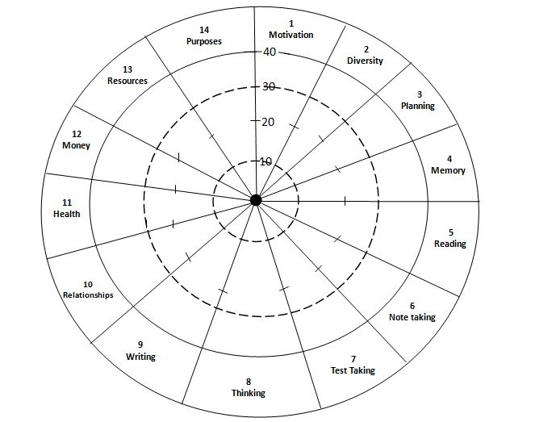
This is a tool to discover the strengths and weaknesses of a person in a figurative way, in the wheel form. The wheel strikingly depicts how strong or how weak a person is, in the chosen areas. The strength or weakness is plotted radially in the wheel, based on the marks scored by an individual in various areas. Any individual can assess himself or herself, by responding to the questionnaire under each area, honestly and sincerely. Mentors must see that the wheel is plotted by each student at the beginning of each semester so that any possible help in the form of counselling can be given to them.
- 14 areas are covered in the Discovery Wheel. These are Motivation, diversity, Planning, Reading, Note taking, Test taking, Thinking, Writing, Relationships, Health, Money, Resources, and Purpose. Each area has 8 statements related to the area.
- Read the statements carefully. For each statement award yourself points for each one using the following criterion

- 5 Points This statement is always or almost always true of me
- 4 Points This statement is often true of me
- 3 Points This statement is sometimes true of me
- 2 Points This statement is seldom true of me
- 1 Point This statement is never or almost never true of me.
- Then add up the total point for each section and shade the Discovery Wheel. The shaded parts indicate areas where you may want to improve.

- MOTIVATION
- 1.____5__________ I start each semester highly motivated, and I stay that way.
- 2.____5__________ I know what I want to get from my education.
- 3.____5__________ I enjoy learning
- 4.____4__________ I study even when distracted by activities of lower priority.
- 5.____5__________ I am satisfied with how I progress toward achieving goals.
- 6.____4__________ Studying is important and I allow adequate time for it
- 7.____5__________ I am excited about the courses I take.
- 8_____5__________ I have a clear idea of the benefits I expect to get from my education
- _____38_________ Total score (1) Motivation
- DIVERSITY
- 1.______5________I am aware of my cultural biases and open to understanding people with different backgrounds.
- 2.______5________ I build rewarding relationships with people from other cultures and races.
- 3._____5_________ I can point out examples of discrimination and effectively respond to them
- 4._____5_________ I study in a way that draws on my preferred learning styles.
- 5______5_________ I practice using several different learning styles when I study.
- 6._____5__________ I take specific steps to make a successful transition into higher education
- 7._____5_________ I use a sound process for defining my special areas of interest and choosing an academic major or program of study.
- 8.______4________ I effectively integrate schooling with my family and work lives.
_____39________ Total Score (2) Diversity

- PLANNING
- 1.______4________ I periodically refine my long-term goals.
- 2.______5________ I regularly define short term goals
- 3.______4_______ I write a plan for each day and each week.
- 4.______5_______ I assign priorities to what I choose to do each day.
- 5.______5_______ I plan review time so I do not have to cram before tests.
- 6.______5_______ I plan regular recreation time.
- 7.______4_______ I adjust my study time to meet the demands of individual courses.
- 8.______4_______ I have adequate time each day to accomplish what I plan.
______36______ Total score (3) planning
- MEMORY
- 1.______5______ I am confident in my ability to remember
- 2.______5______ I remember people’s names
- 3.______5______ At the end of a lecture I can summarize what was presented.
- 4.______5______ I apply techniques that enhance my memory kills
- 5.______4______ I can recall information when I am under pressure
- 6.______4______ I remember important information clearly and easily
- 7.______5______ I can jog my memory when I have difficulty recalling
- 8._____33______ Total score (4) Memory

- READING

- 1.____4_______ I Preview and review reading assignments
- 2.____4_______ When reading, I underline or highlight important passages.
- 3._____5______ When I read, I ask questions about the material
- 4._____5______ When I read textbooks, I am alert and awake.
- 5._____4______ I relate what I read to my life.
- 6._____4______ I select a reading strategy to fit the type of material I`m reading
- 7._____5______ I take effective notes when I read
- 8._____5______ When I do not understand what I am reading, I note my question and find my answers.
- ______36_____ Total score (4) Reading
- NOTE TAKING

- 1._____5____ When I am in class I focus my attention
- 2._____5____ I take notes in class
- 3._____5____ I am aware of various methods for taking notes and choose that work best for me.
- 4._____5____ My notes are valuable for review.
- 5._____4____ I review class notes within 24 hours
- 6._____4____ I distinguish important material and notice key phrases in a lecture.
- 7._____4____ I copy material the instructor writes on the board or overhead projector
- 8._____5____ I can put important concepts into my own words
- ____37_____ Total score (6) Note taking

- TEST TAKING

- 1._____5____ I feel confident and calm during an exam
- 2.____5____ I can manage my time during exams and I can able to complete them.
- 3.____5____ I can predict test questions
- 4.____5____ I can examine essay questions considering what I know and come to new original conclusions during a test
- 5.____5____ I adapt my test taking strategy to the kind of test I am taking
- 6.____4____ I understand what essay questions ask and can answer them completely and accurately.
- 7.____5____ I start reviewing for tests at the beginning of the term and review regularly.
- 8.____5____ My sense of personal worth is independent of my personal scores.
- ___39____ Total score (7) Test taking

- THINKING
- 1. ____5____ I have flashes of insight, and solutions to problems appear to me at unusual times.
- 2.____5_____ I use brainstorming to generate solutions to a variety of problems.
- 3.____4_____ When I get stuck on a creative project, I use specific methods to get unstuck
- 4.____5_____ I see problems and decisions as opportunities for learning and personal growth
- 5.____5_____ I am willing to consider different points of view and alternative solutions
- 6.____5_____ I can state the assumptions that underline a series of assertions.
- 7.____5_____ I can detect common errors in logic
- 8.____5_____ I approach courses in mathematics and science with confidence
- ____40____ Total score (8) Thinking

- WRITING
- 1.____5____ I approach writing with confidence
- 2.____5____ I can effectively plan a large writing assignment
- 3.____5____ I create first drafts without stopping to edit or criticize my writing
- 4.____5____ I revise my writing for clarity, accuracy, and coherence.
- 5.___ 5_____My writing affirms women and is free of sexist expressions.
- 6.____5____ When writing. I accurately credit ideas and facts from other
- 7.____5_____ I know how to prepare and deliver effective speeches.
- 8.____5_____ I am confident when I speak before others.
- ____40____ Total score (9) Writing

- RELATIONSHIPS
- 1._____5____ I develop and maintain mutually supportive relationships
- 2.____5_____ I am candid with others about who I am, what I feel and what I want.
- 3.____5_____ Other people tell me that I am a good listener.
- 4.____5_____ I communicate my upset and anger without blaming others.
- 5.____5_____ I make and keep promises that stretch me to meet my potentials.
- 6.____4_____ I can learn from various instructors with different teaching styles.
- 7._____5____ I can make friends and create valuable relationship in a new place.
- 8.____5_____ I am open to being with people I do not especially like in order to learn from them.
- ___39____ Total score (10) Relationships

- HEALTH
- 1.____5____ I have enough energy to study and still enjoy other areas of my life.
- 2.____4____ I exercise regularly.
- 3.____5____ My emotional health support my ability to learn
- 4.____5____ If the situation calls for it, I have enough reserve energy to put in a long day.
- 5.____5___ I notice changes in my physical condition and respond effectively.
- 6. ___4____ I notice changes in my psychological condition and respond effectively.
- 7.____5____ I am in control of the bad habits such as smoking, alcohol and drugs
- 8.____5___ My food and sleeping habits contribute to my health.
- ____38___ Total score (11) Health

- MONEY

- 1.____5____ I budget my money and I am in control of my personal finances.
- 2.____5____ I am confident that I will have enough to complete the education I want.
- 3.____4____ I have a clear picture of the financial resources available to me to pay for my education.
- 4.____5____ I can make a little money go a long way.
- 5.____4____ My education supports my long rang financial goals.
- 6.____5____ I repay my debts on time
- 7.___5____ My sense of personal worth is independent of my financial condition
- 8.____5___ I make regular deposits to my savings accounts.
- ___38____ Total score (12) Money

- RESOURCES
- 1. ____5___ I can effectively use libraries to find the resources and information I want.
- 2.____5___ I am aware of the services offered by my school as learning experiences.
- 3.____5___ I use my job or other activities outside of school as learning experiences.
- 4.____5___ I take on projects that can make a difference in other people’s lives
- 5.___5____ I know where to get help in my community for a variety of problems
- 6.____5___ My relationships with friends, family and other support my educational goals.
- 7.____5___ I think of my mistakes as valuable opportunities to learn.
- 8.____5___ I see the world’s problems as opportunities for me to participate and contribute.
- ____40___ Total score (13) Resources

- PURPOSE

- 1.____5___ I see learning as a life process
- 2. ___5____ I relate school to what I plan to do for the rest of my life.
- 3. ___5____ I learn by contributing to others.
- 4. ___5____ I revise my plans as I learn, change, and grow.
- 5. ___5____ I am clear about my purpose in life.
- 6. ___5____ I know that I am responsible for my own education
- 7.____5___ I take responsibility for the quality of my life
- 8. ___5____ I am willing to accept challenges even when I am not sure how to meet them.
- ___40____ Total score (14) purpose

Chaitanya Bharathi Institute of Technology(Autonomous),Hyderabad-75
X. Student’s(Mentee’s) Personal Details
Student Profile:
Name of the Student BELLAMKONDA MEGHANA
Branch & Section : AIML- J
Hall Ticket number : 1601-21-729-303
Category: Convenor (OC)
Contact ph.no7330749374
Alt.ph. no./ local guardian no. 7330749374
email ID: meghanareddybellamkonda970@gmail.com
Parents’ Details:
Father’s Name : BELLAMKONDA RAMCHANDRAREDDY Occupation : DRIVER Mother’s Name: BELLAMKONDA SRILATHA Occupation : HOUSE WIFE
Contact No :7330749374 email ID : -
Contact Address: H-No:4-5-2,NTPC,RAMAGUNDAM,PEDDAPALLI.
Previous Academic Performance:
Sno | Class | Year of passing | % Of marks / Grade | School/ College
1 | 10th / Equivalent | 2019 | 9.7 CGPA | RAOS HIGH SCHOOL
2 | 12th / Equivalent | 2022 | 9.75 CGPA | DR BRAMBEDKAR POLYTECHNIC FOR WOMEN

EAMCET/ JEEE or any other examination Position details or merit awards (if any):
- In TS POLYCET ENTRANCE EXAM I secured 6440 STATE RANK.
- In TS ECET ENTRANCE EXAM I secured 334 STATE RANK.
- ……………………………………………………………………………………………………………………
Hobbies : playing cricket, reading books, self-exploration of new things.

Career Plans : A highly enthusiastic and hard-working individual looking for a top-level position for maximum utilization of my skills and knowledge.

Strengths and Weakness: Strong desire, creativity, and leadership.
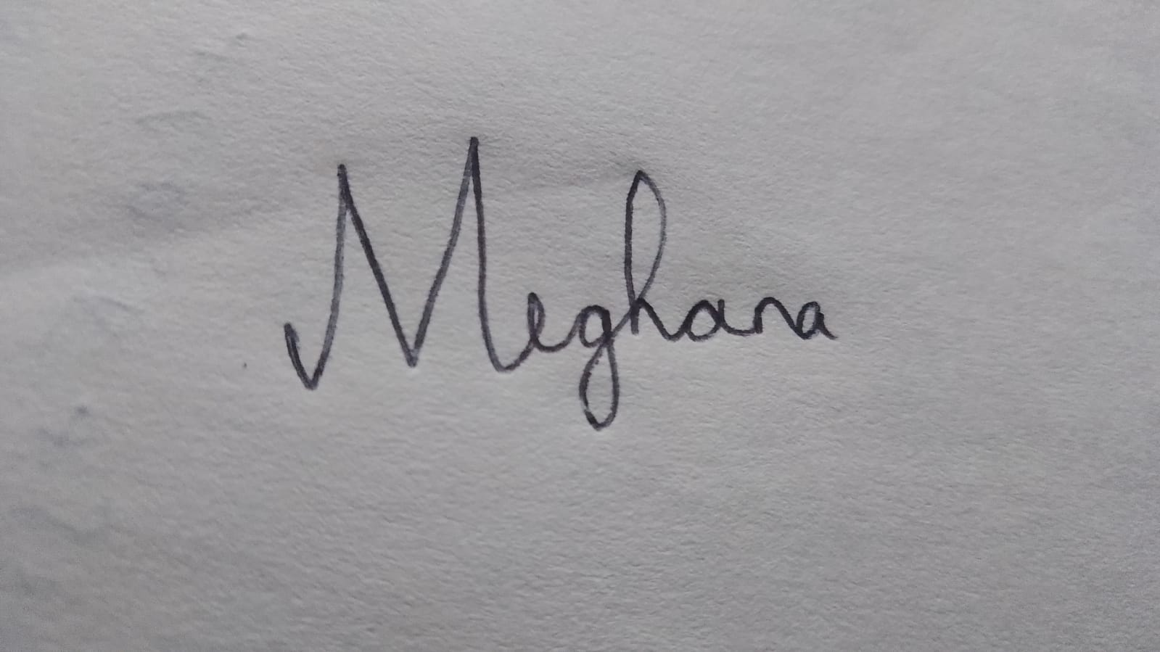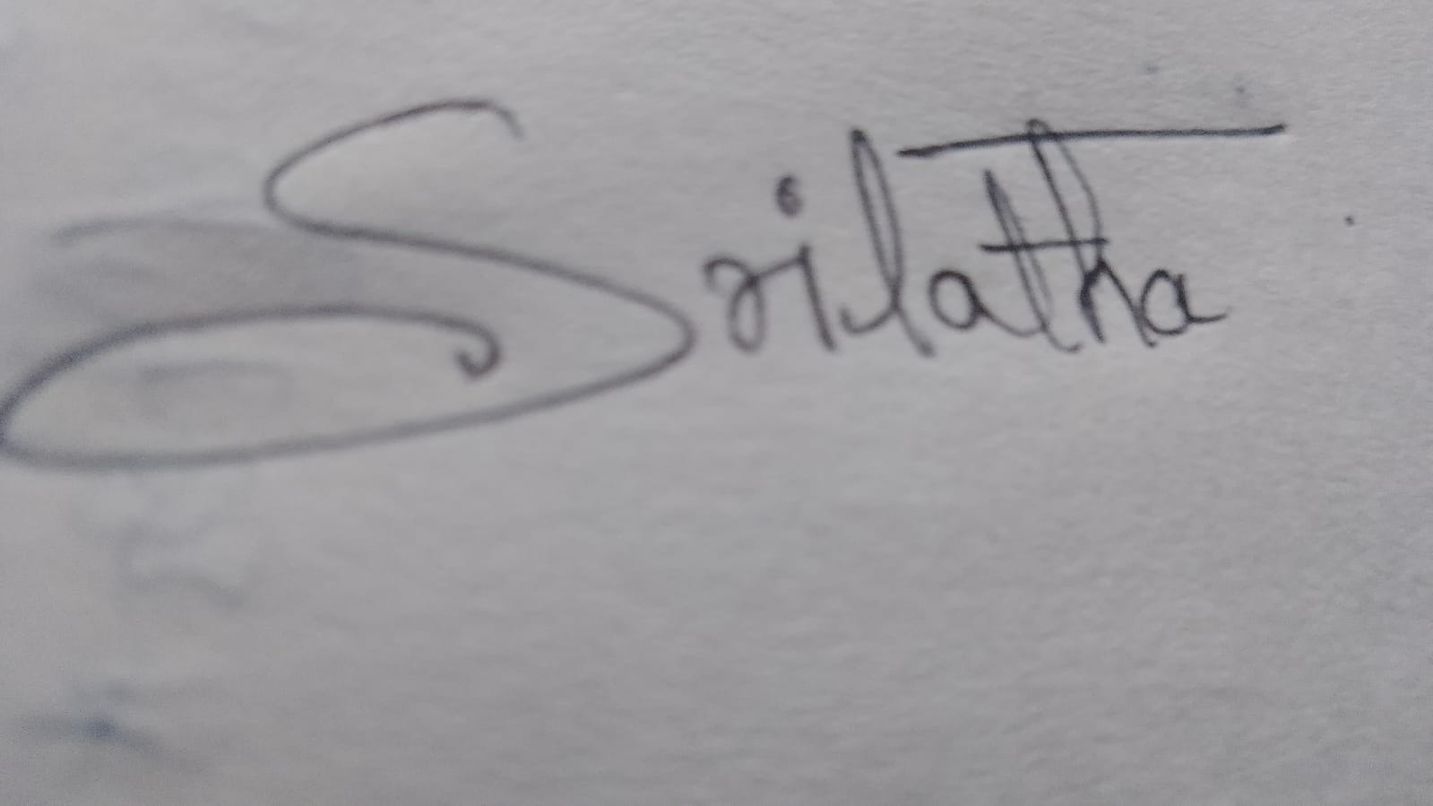
Signature of the student Signature of the Parent
Date: 14-04-2023 Date: 14-04-2023

Name and Signature of the Mentor: Sri. A Venkata Siva Rao
XI. DETAILS OF STUDENT’S INVOLVEMENT IN THE STUDENT INDUCTION PROGRAMME(SIP) CONDUCTED BY THE INSTITUTE
(To be filled by the student)
1 . Attendance in the Induction Programme (No. of sessions attended/Conducted):
---------------Lateral Entry-----------------------------------------------------------------------------------------
2. Which session of the SIP was impressive and why ?
---------------Lateral Entry-----------------------------------------------------------------------------------------
3 . Which session was not at all useful and why ?
---------------Lateral Entry-----------------------------------------------------------------------------------------
4 . Whether the academic rules , examination rules, Code of Conduct were explained with clarity by the resource person and / or the mentor ? Do you have any doubts ?
---------------Lateral Entry-----------------------------------------------------------------------------------------
5 . Whether the clubs related to Co-curricular& Extra-curricular activities were introduced ? Did you or do you wish to join any of them ?
---------------Lateral Entry-----------------------------------------------------------------------------------------
6 . Was the course on Human Values taught ? Do you have anything to say on that ?
---------------Lateral Entry-----------------------------------------------------------------------------------------
7 . Did you understand the need for keeping the campus clean and green and yourself Fit ?
---------------Lateral Entry-----------------------------------------------------------------------------------------
8 . Was the campus tour organised for you? Are you aware of your campus now?
---------------Lateral Entry-----------------------------------------------------------------------------------------
9 . Was the importance of Fine Arts in support of a Professional career driven ?
---------------Lateral Entry-----------------------------------------------------------------------------------------
Signature of the Student Signature of the Mentor Head
Director – SA&P Principal
XII. 1st ORIENTATION BY THE CONCERNED MENTOR
( At the beginning of the Semester; 1st or3rd as the case may be)
1 . Was the vision, mission and Quality policy of the institute explained by the mentor ?
---------------------------Lateral Entry------------------------------------------------------------------------------
2 . Was the awareness created in you about the vision & mission of the department and the need for falling in line with that of the institute?
---------------------------Lateral Entry------------------------------------------------------------------------------
3 . Were the Graduate attributes, COs , POs, PEOs, PSOs and their role in Outcome Based Education explained?
---------------------------Lateral Entry------------------------------------------------------------------------------
4 . Was the existence of various types of courses (HSSC, BSC,BESC,PCC,PEC ,OEC, Mandatory Courses) in the programme and their need explained?(Refer Rule II of Academic Rules)
---------------------------Lateral Entry------------------------------------------------------------------------------
5. Was the importance of Project Works/Seminars/Internships/Industrial Visits explained? (Refer Rule V of academic Rules)
---------------------------Lateral Entry------------------------------------------------------------------------------
6 . Was the scope and opportunity for taking Swayam/ MOOCs course and the concept of award of Major/Minor degree explained? (Refer Rule XII of Academic Rules)
---------------------------Lateral Entry------------------------------------------------------------------------------
7 . Was the concept of Credit system, GPA, SGPA and CGPA explained? ( Refer Rule VI of Academic Rules)
---------------------------Lateral Entry------------------------------------------------------------------------------
8 . Were the details about duration and academic credentials of Industrial visits / Internships explained? (Refer Rule XIII of Academic Rules)
---------------------------Lateral Entry------------------------------------------------------------------------------
9 . Was the requirement of Activity points explained? (Refer to Rule XIV of Academic Rules)
---------------------------Lateral Entry------------------------------------------------------------------------------
10 . Was the eligibility criteria for award of Degree (Major/ Additional Major/ Honour) explained ? (Refer to Rule XVIII of Academic Rules)
---------------------------Lateral Entry------------------------------------------------------------------------------
11 . Were the additional rules for lateral entry students explained? (Applicable only for lateral entry students. Refer Rule XXII of Academic Rules)
---------------------------Lateral Entry------------------------------------------------------------------------------
12. Was the Academic Rule book given to you and explained by the concerned authority?
---------------------------Lateral Entry------------------------------------------------------------------------------
13 . Was the Code of Conduct introduced to you and was made available?
---------------------------Lateral Entry------------------------------------------------------------------------------

14. Was the existence of an R&E Hub, EDC and I&I centre informed and their importance explained?
---------------------------Lateral Entry------------------------------------------------------------------------------
15. Whether the importance of participating in Social service, Community service, Extension activities, Outreach activities & NSS activities explained and the available facilities in the campus introduced ?
---------------------------Lateral Entry------------------------------------------------------------------------------

Signature of the Student Signature of the parent

Signature of the Mentor Signature of HoD

Director – SA&P Principal

XIII. STUDENT’s PROGRESS RECORD
- BE / B.Tech./M.E/M.Tech/M.C. A/M.B.A ( ________ ) I-SEMESTER

- DISCOVERY WHEEL for I Semester

(B). DESCRIBE YOUR GOALS FOR THIS SEMESTER AND THE PATH WAYS PLANNED TO REACH THEM:

(C). Monthly Attendance Details: (T: total classes P: Present)
Sno | Course | 1st Month |  | 2rd Month |  | 3rd Month |  | 4th Month |  | Remarks
Sno | Course | T | P | T | P | T | P | T | P
1
2
3
4
5
6
7
8
9
10
Total
Percentage
(D). Details of Marks Obtained in Assignments/Quizzes/Mid-exams and SEE

Sno | Course | Assignment / Quiz  Max.Marks: |  |  | Mid-1 (20) | Mid-2 (20) | Mid-Final | External | Credits
Sno | Course | A1 | A2 | A3
1
2
3
4
5
6
7
8
9
10
SGPA:

Position in the class: CGPA:

(E). Details of Participation in Co-curricular and Extra-Curricular activities:
(i). Details of participation in Co-curricular activities

(ii). Details of participation in Extra-Curricular activities

(iii). Awards/ Honours/ Appreciations

(F). Details of Conduct and Character
(i). Involvement in any activity that reflects the good conduct of the student:

(ii). Awards/ Appreciations won (if any ):

(iii). Involvement in any activity violating the code of conduct:

(iv). Punishments given / Penalty imposed (if any):

(G). Any other information / Observations

Signature of the student signature of Parent

Mentor’s initial Remarks: (Please specify whether the student needs counselling in any direction )

Signature of the Mentor Signature of the Head

Signature of Director (SA&P) Principal

COUNSELING NOTES
Sno | Date | Remarks | Signature

Signature of the Mentor Signature of the Head

Director – SA&P PRINCIPAL
- BE / B.Tech./M.E./M.Tech./M.C.A/M.B.A/( ________ ) II-SEMESTER
(A). DISCOVERY WHEEL for II Semester

(B). DESCRIBE YOUR GOALS FOR THIS SEMESTER AND THE PATH WAYS PLANNED TO REACH THEM:

- .Monthly Attendance Details: (T: total classes P: Present)
Sno | Course | 1st Month |  | 2rd Month |  | 3rd Month |  | 4th Month |  | Remarks
Sno | Course | T | P | T | P | T | P | T | P
1
2
3
4
5
6
7
8
9
10
Total
Percentage
(D).Details of Marks Obtained in Assignments/Quizzes/Mid-exams and SEE

Sno | Course | Assignment / Quiz (10/5) |  |  | Mid-1 (20) | Mid-2 (20) | Mid-Final  (25/30) | External | Credits
Sno | Course | A1 | A2 | A3
1
2
3
4
5
6
7
8
9
10
SGPA:

Position in the class: CGPA:

Signature of the Mentor Signature of the Head

(E ).Details of Participation in Co-curricular and Extra-Curricular activities:
(i). Details of participation in Co-curricular activities

(ii). Details of participation in Extra-Curricular activities

(iii). Awards/ Honours/ Appreciations

(F). Details of Conduct and Character
(i). Involvement in any activity that reflects the good conduct of the student:

(ii). Awards/ Appreciations won (if any ):

(iii).Involvement in any activity violating the code of conduct:

(iv). Punishments given / Penalty imposed(if any):

(G). Any other information / Observations

Signature of the student signature of Parent

Mentor’s initial Remarks : ( Please specify whether the student needs counselling in any direction )

Signature of the Mentor Signature of the Head

Signature of Director(SA&P) Principal

COUNSELING NOTES
Sno | Date | Remarks | Signature

Signature of the Mentor Signature of the Head

Director – SA&P PRINCIPAL

- BE / B.Tech./M.E/MTech./M.C.A/M.B.A ( B.E ) III-SEMESTER

(A). DISCOVERY WHEEL for III Semester

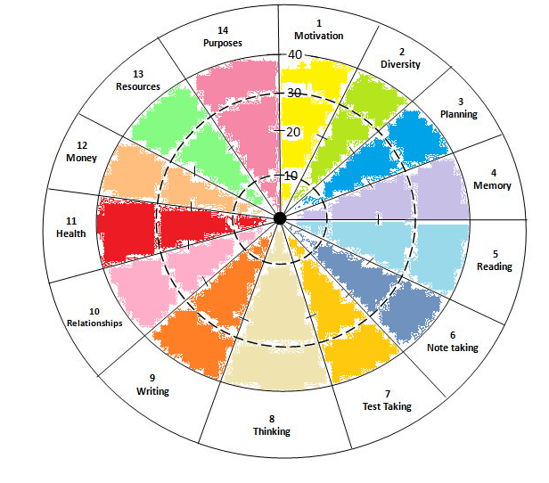

(B). DESCRIBE YOUR GOALS FOR THIS SEMESTER AND THE PATH WAYS PLANNED TO REACH THEM:

(C ). Monthly Attendance Details: (T: total classes P: Present)
Sno | Course | 1st Month |  | 2rd Month |  | 3rd Month |  | 4th Month |  | Remarks
Sno | Course | T | P | T | P | T | P | T | P
1 | Introduction to Algorithms & Data Structures | 10 | 10 | 12 | 11 | 12 | 10 | 11 | 10
2 | Discrete Mathematical Structures | 10 | 10 | 10 | 10 | 10 | 10 | 9 | 9
3 | Group Theory and Its Applications | 10 | 10 | 10 | 10 | 11 | 10 | 10 | 10
4 | Digital Logic Design | 11 | 11 | 12 | 12 | 12 | 11 | 12 | 12
5 | Basic Electrical Engineering | 11 | 11 | 11 | 11 | 10 | 10 | 10 | 10
6 | Universal Human Values -II Understanding Harmony | 10 | 10 | 10 | 10 | 11 | 10 | 12 | 10
7 | Introduction to Inference & Interpretation | 3 | 3 | 4 | 3 | 4 | 3 | 2 | 2
8 | Algorithms Lab-1 | 11 | 11 | 12 | 12 | 12 | 12 | 10 | 10
9 | Introduction to Inference & Interpretation lab | 8 | 8 | 8 | 8 | 10 | 10 | 8 | 8
Total |  | 354/359
Percentage |  | 97%
(D)Details of Marks Obtained in Assignments/Quizzes/Mid-exams& SEE

Sno | Course | Assignment / Quiz (10/5) |  |  | Mid-1 (20) | Mid-2 (20) | Mid-Final  (40) | External | Credits
Sno | Course | A1 | A2 | A3
1 | Introduction to Algorithms & Data Structures | 5 | 4 | 4.5 | 17 | 19 | 37
2 | Discrete Mathematical Structures | 5 | 4 | 4.5 | 16 | 13 | 32
3 | Group Theory and Its Applications | 5 | 5 | 5 | 20 | 19 | 39
4 | Digital Logic Design | 5 | 4.5 | 5 | 19 | 14 | 37
5 | Basic Electrical Engineering | 5 | 5 | 5 | 14 | 19 | 38
6 | Universal Human Values -II Understanding Harmony | 5 | 4.5 | 5 | 18 | 19 | 37
7 | Introduction to Inference & Interpretation | - | - | - | - | - | -
8 | Algorithms Lab-1 | 5 | 5 | 5 | 25 | 25 | 50
9 | Introduction to Inference & Interpretation lab | 5 | 5 | 5 | 24 | 22 | 46
SGPA: |  |  |  |  |  |  |  |  | 78.90%

Position in the class: CGPA:7.5

Signature of the Mentor Signature of the Head

(E ).Details of Participation in Co-curricular and Extra-Curricular activities:
(i). Details of participation in Co-curricular activities
Participated in college sports, events, and club activities.
Participated in the workshop conducted by MOI on IOT.
Participated in the decipher event conducted by COSC CBIT.
Participated in the quiz competitions on MY GOV platform.
Participated in speaker sessions conducted by various clubs.

(ii). Details of participation in Extra-Curricular activities
Participated in social service and awareness events.

(iii). Awards/ Honours/ Appreciations
Obtained course completion certificates and badges online.

(F). Details of Conduct and Character
(i). Involvement in any activity that reflects the good conduct of the student:
Participated in awareness camp on blood cancer and social hygiene.
(ii). Awards/ Appreciations won (if any ):
Certified on various online platforms on course completion.
(iii).Involvement in any activity violating the code of conduct:
-
(iv). Punishments given / Penalty imposed(if any):
-
(G). Any other information / Observations
In this semester I have focussed on doing courses online in various platforms and learnt new things.

Signature of the student signature of Parent

Mentor’s initial Remarks : ( Please specify whether the student needs counselling in any direction )

Signature of the Mentor Signature of the Head

Signature of Director(SA&P) Principal

COUNSELING NOTES
Sno | Date | Remarks | Signature
1  2  3  4  5  6  7  8  9  2 | 27-10 2027  27-10 2027  27-10 2027  27-10 2027  27-10 2027  27-10 2027  27-10 2027  27-10 2027  27-10 2027 | evaluation system  Motivated to complete at least one or two certification courses with global recognition  Informed to be prepared for the slip tests and asked to submit all assigned works by subject teacher on time  Alarmed on upcoming class tests and advised to clear the subject doubts with concerned faculty  Discussed on class test performance and areas to improve  Informed by mentee that he was doing web development certification  Advised to practice python programming in coding platforms.  Informed me that Internshala certification course was successfully  completed advised him to focus on upcoming semester end  examinations

Signature of the Mentor Signature of the Head

Director- SA&P PRINCIPAL

- BE / B.Tech./M.E/M.Tech./M.C.A/M.B.A ( B.E ) IV-SEMESTER
(A). DISCOVERY WHEEL for IV Semester

(B). DESCRIBE YOUR GOALS FOR THIS SEMESTER AND THE PATH WAYS PLANNED TO REACH THEM:
(C ). Monthly Attendance Details: (T: total classes P: Present)
Sno | Course | 1st Month |  | 2rd Month |  | 3rd Month |  | 4th Month |  | Remarks
Sno | Course | T | P | T | P | T | P | T | P
1 | Modern Computer System Architecture | 9 | 9 | 8 | 8 | 9 | 8 | 8 | 8
2 | Database Systems | 10 | 10 | 10 | 10 | 10 | 10 | 10 | 10
3 | Linear Regression Modelling for Data Analysis | 8 | 8 | 9 | 9 | 10 | 10 | 8 | 5
4 | Strategic Entrepreneurship | 10 | 10 | 9 | 9 | 8 | 6 | 10 | 10
5 | Signal Processing | 10 | 10 | 9 | 8 | 10 | 10 | 10 | 10
6 | Robotics and Automation | 10 | 10 | 9 | 9 | 10 | 9 | 10 | 10
7 | Robotics and Automation Lab | 10 | 10 | 12 | 12 | 12 | 12 | 10 | 10
8 | Database Systems Lab | 10 | 10 | 10 | 10 | 11 | 11 | 12 | 12
9 | Building Large, Reliable Software Systems Lab | 12 | 12 | 12 | 12 | 10 | 10 | 10 | 9
Total |  | 333/347
Percentage |  | 96%

(D)Details of Marks Obtained in Assignments/Quizzes/Mid-exams and SEE

Sno | Course | Assignment / Quiz (10/5) |  |  | Mid-1 (20) | Mid-2 (20) | Mid-Final  (40) | External | Credits
Sno | Course | A1 | A2 | A3
1 | MCSA | 10 | 10 | 5 | 18 | 17 | 37
2 | Database Systems | 10 | 10 | 5 | 26 | 20 | 40
3 | LRMDA | 10 | 10 | 4 | 19 | 20 | 40
4 | Strategic Entrepreneurship | 10 | 10 | 5 | 19.5 | 20 | 40
5 | Signal Processing | 10 | 10 | 5 | 20 | 16 | 40
6 | Robotics & Automation | 10 | 10 | 5 | 16 | 19.5 | 50
7 | Robotic Automation Lab | 10 | 10 | 5 | 20 | 20 | 50
8 | BSRS Lab | 10 | 10 | 5 | 20 | 20 | 50
SGPA: |  |  |  |  |  |  |  |  | 94%

Position in the class: CGPA:

Signature of the Mentor Signature of the Head

(E ).Details of Participation in Co-curricular and Extra-Curricular activities:
(i). Details of participation in Co-curricular activities
Participated in speaker sessions conducted by various clubs.
Participated in college sports, events, and club activities.
(ii). Details of participation in Extra-Curricular activities
Participated in social service and awareness events.

(iii). Awards/ Honours/ Appreciations
-

(F). Details of Conduct and Character
(i). Involvement in any activity that reflects the good conduct of the student:
Participated in rural development program and harithaharam.

(ii). Awards/ Appreciations won (if any ):
Participation certificates and medal of honour.

(iii).Involvement in any activity violating the code of conduct:
-

(iv). Punishments given / Penalty imposed(if any):
-

(G). Any other information / Observations

Signature of the student signature of Parent

Mentor’s initial Remarks : ( Please specify whether the student needs counselling in any direction )

Signature of the Mentor Signature of the Head

Signature of Director(SA&P) Principal

COUNSELING NOTES
Sno | Date | Remarks | Signature

Signature of the Mentor Signature of the Head

Director- SA&P PRINCIPAL

- BE / B.Tech. (B.E ) V-SEMESTER

(A). DISCOVERY WHEEL for V Semester

(B). DESCRIBE YOUR GOALS FOR THIS SEMESTER AND THE PATH WAYS PLANNED TO REACH THEM:
(C ). Monthly Attendance Details: (T: total classes P: Present)

Sno | Course | 1st Month |  | 2rd Month |  | 3rd Month |  | 4th Month |  | Remarks
Sno | Course | T | P | T | P | T | P | T | P
1
2
3
4
5
6
7
8
9
10
Total
Percentage

Signature of the student: Signature of the parent:
(D). Details of Marks Obtained in Assignments/Quizzes/Mid-exams and SEE
Sno | Course | Assignment / Quiz (10/5) |  |  | Mid-1 (20) | Mid-2 (20) | Mid-Final  (25/30) | External | Credits
Sno | Course | A1 | A2 | A3
1
2
3
4
5
6
7
8
9
10
SGPA:

Position in the class: CGPA

Signature of the Mentor Signature of the Head

(E).Details of Participation in Co-curricular and Extra-Curricular activities:
(i). Details of participation in Co-curricular activities

(ii). Details of participation in Extra-Curricular activities

(iii). Awards/ Honours/ Appreciations

(F). Details of Conduct and Character
(i). Involvement in any activity that reflects the good conduct of the student:

(ii). Awards/ Appreciations won (if any ):

(iii).Involvement in any activity violating the code of conduct:

(iv). Punishments given / Penalty imposed(if any):

(G). Any other information / Observations

Signature of the student signature of Parent

Mentor’s initial Remarks : ( Please specify whether the student needs counselling in any direction )

Signature of the Mentor Signature of the Head

Signature of Director(SA&P) Principal

COUNSELING NOTES
Sno | Date | Remarks | Signature

Signature of the Mentor Signature of the Head

Director – SA&P PRINCIPAL

- BE / B.Tech. ( ________ ) VI-SEMESTER

(A). DISCOVERY WHEEL for VI Semester

(B). DESCRIBE YOUR GOALS FOR THIS SEMESTER AND THE PATH WAYS PLANNED TO REACH THEM:

(C ). Monthly Attendance Details: (T: total classes P: Present)

Sno | Course | 1st Month |  | 2rd Month |  | 3rd Month |  | 4th Month |  | Remarks
Sno | Course | T | P | T | P | T | P | T | P
1
2
3
4
5
6
7
8
9
10
Total
Percentage

Signature of the student: Signature of the parent:
(D).Details of Marks Obtained in Assignments/Quizzes/Mid-exams and SEE

Sno | Course | Assignment / Quiz (10/5) |  |  | Mid-1 (20) | Mid-2 (20) | Mid-Final  (25/30) | External | Credits
Sno | Course | A1 | A2 | A3
1
2
3
4
5
6
7
8
9
10
SGPA:

Position in the class: CGPA:

Signature of the Mentor Signature of the Head

(E).Details of Participation in Co-curricular and Extra-Curricular activities:
(i). Details of participation in Co-curricular activities

(ii). Details of participation in Extra-Curricular activities

(iii). Awards/ Honours/ Appreciations

(F). Details of Conduct and Character
(i). Involvement in any activity that reflects the good conduct of the student:

(ii). Awards/ Appreciations won (if any ):

(iii).Involvement in any activity violating the code of conduct:

(iv). Punishments given / Penalty imposed(if any):

(G). Any other information / Observations

Signature of the student signature of Parent

Mentor’s initial Remarks : ( Please specify whether the student needs counselling in any direction )

Signature of the Mentor Signature of the Head

Signature of Director(SA&P) Principal

COUNSELING NOTES
Sno | Date | Remarks | Signature

Signature of the Mentor Signature of the Head

Director – SA&P PRINCIPAL

- BE / B.Tech. ( ________ ) VII-SEMESTER
(A). DISCOVERY WHEEL for VII Semester

(B). DESCRIBE YOUR GOALS FOR THIS SEMESTER AND THE PATH WAYS PLANNED TO REACH THEM:

(C ). Monthly Attendance Details: (T: total classes P: Present)

Sno | Course | 1st Month |  | 2rd Month |  | 3rd Month |  | 4th Month |  | Remarks
Sno | Course | T | P | T | P | T | P | T | P
1
2
3
4
5
6
7
8
9
Total
Percentage

Signature of the student: Signature of the parent:
(D).Details of Marks Obtained in Assignments/Quizzes/Mid-exams and SEE

Sno | Course | Assignment / Quiz (10/5) |  |  | Mid-1 (20) | Mid-2 (20) | Mid-Final  (25/30) | External | Credits
Sno | Course | A1 | A2 | A3
1
2
3
4
5
6
7
8
9
SGPA:

Position in the class: CGPA:

Placements or any other exams:

Signature of the Mentor Signature of the Head

(E).Details of Participation in Co-curricular and Extra-Curricular activities:
(i). Details of participation in Co-curricular activities

(ii). Details of participation in Extra-Curricular activities

(iii). Awards/ Honours/ Appreciations

(F). Details of Conduct and Character
(i). Involvement in any activity that reflects the good conduct of the student:

(ii). Awards/ Appreciations won (if any ):

(iii).Involvement in any activity violating the code of conduct:

(iv). Punishments given / Penalty imposed(if any):

(G). Any other information / Observations

Signature of the student signature of Parent

Mentor’s initial Remarks : ( Please specify whether the student needs counselling in any direction )

Signature of the Mentor Signature of the Head

Signature of Director(SA&P) Principal

COUNSELING NOTES
Sno | Date | Remarks | Signature

Signature of the Mentor Signature of the Head

Director- SA&P PRINCIPAL

- BE / B.Tech. ( ________ ) VIII-SEMESTER

(A). DISCOVERY WHEEL for VIII Semester

(B). DESCRIBE YOUR GOALS FOR THIS SEMESTER AND THE PATH WAYS PLANNED TO REACH THEM:

(C ). Monthly Attendance Details: (T: total classes P: Present)
Sno | Course | 1st Month |  | 2rd Month |  | 3rd Month |  | 4th Month |  | Remarks
Sno | Course | T | P | T | P | T | P | T | P
1
2
3
4
5
6
7
8
9
Total
Percentage

Signature of the student: Signature of the parent:
(D).Details of Marks Obtained in Assignments/Quizzes/Mid-exams and SEE

Sno | Course | Assignment / Quiz / Quiz (10/5) |  |  | Mid-1 (20) | Mid-2 (20) | Mid-Final  (25/30) | External | Credits
Sno | Course | A1 | A2 | A3
1
2
3
4
5
6
7
8
9
SGPA:
Position in the class: CGPA:

Placements or any other exams:

Signature of the Mentor Signature of the Head

(E).Details of Participation in Co-curricular and Extra-Curricular activities:
(i). Details of participation in Co-curricular activities

(ii). Details of participation in Extra-Curricular activities

(iii). Awards/ Honours/ Appreciations

(F). Details of Conduct and Character
(i). Involvement in any activity that reflects the good conduct of the student:

(ii). Awards/ Appreciations won (if any ):

(iii).Involvement in any activity violating the code of conduct:

(iv). Punishments given / Penalty imposed(if any):

(G). Any other information / Observations

Signature of the student signature of Parent

Mentor’s initial Remarks : ( Please specify whether the student needs counselling in any direction )

Signature of the Mentor Signature of the Head

Signature of Director (SA&P) Principal

COUNSELING NOTES
Sno | Date | Remarks | Signature

Signature of the Mentor Signature of the Head

Director- SA&P PRINCIPAL

XIV. Name and Signatures of the Counsellors:
I-Semester: ……………………………………………….. II-Semester: …………………………………………
III-Semester: ……………………………………………….. IV-Semester: ………………………………………..
V-Semester: ……………………………………………….. VI-Semester: ………………………………………..
VII-Semester: ……………………………………………….. VIII-Semester: ………………………………………
DETENTION DETAILS (if any):
I-Semester | II-Semester | III-Semester | IV-Semester | V-Semester | VI-Semester | VII-Semester

BACKLOG DETAILS (if any)
Sno | Semester | Courses | Details of the cleared courses in the subsequent semesters
1 | I-Semester
2 | II-Semester
3 | III-Semester
4 | II-Semester
5 | V-Semester
6 | VI-Semester
7 | VII-Semester
8 | VIII-Semester

Sno | Semester | Date | Remarks and Signature of the Head
1 | I-Semester
2 | II-Semester
3 | III-Semester
4 | IV-Semester
5 | V-Semester
6 | VI-Semester
7 | VII-Semester
8 | VIII-Semester

Director-SA&P PRINCIPAL

